# ***Fault/Fracture Related to Lost Circulation***

# **Fault/Fracture Related to Lost Circulation**

## **Introduction**

Lost circulation is one of the most troublesome drilling problems as increasing the drilling or completion cost for the well. Firstly, it is the main contributor to non-productive time (NPT) spent on regaining circulation. For example, lost circulation was responsible for more than 10% of non-productive time (NPT) when drilling in Gulf of Mexico between 1993 and 2003 (Rehm et al.2008). Besides, since cost of drilling fluids amounts to 25% ~ 40% of total drilling costs (Lecolier et al.2005), loss of expensive drilling fluid or slurry will incur additional drilling cost and decrease profit margin.

Lost circulation may occur during drilling, cementing and completion, to some extent, it can be detrimental to well construction and estimated ultimate recovery (EUR). In drilling process, when occuring lost circulation, drilling fluid will enter subsurface formations. Apart from NPT, lost circulation may decrease the fluid level in wellbore and potentially bring about well control issue. Meanwhile, plenty of lost circulation materials (LCM) can lead to pipe corrosion and plugging of downhole tools, such as MWD.

During cementing process, in terms of achieving the best cementing quality, lost circulation is more complicated than other accidents. Lost circulation can form tributary flow into formation and decrease upward velocity of slurry, and eventually induce adverse effects on displacement efficiency. Moreover, lost circulation during cementing process can also lead to well control issue and poor isolation of formation.

In completion process, lost circulation can cause contamination of reservoir. Completion fluid leaking into reservoir not only changes the wettability of rocks and effects permeability, but also increases production time based on efforts to flush out the invaded fluid(Lavrov. 2016). Moreover, as slurry leaking into reservoir, it will harden in reservoir and remain hard for well stimulation, like fracturing and acidizing.

## **Problem statement**

With the development of drilling technology and increase of future oil demand, oil companies extend their operation areas from conventional formations to extreme environment, such as deep water, HPHT zone, polar area, and extra deep formations. Among these drilling processes, lost circulation is extremely money and time consuming due to unit mud costs and non-productive time (NPT). There are plenty of studies devoted to preventing lost circulation scenario and how to cure it (Cook et al. 2011)

Lost circulation along fault and pre-existing fractures is imperative to study. During drilling design process, we try to avoid well trajectory through the geology fault and large pre-existing fault. The well designers are certain that these types of formations will incur lost circulation and other drilling trouble. However, reservoir engineers are more inclined to drill a well through the fault in reservoir, which means large hydrocarbon outlets to improve recovery. Thus, we need to research the mechanism and theory of fault/fractures related to lost circulation, to prevent and cure the lost circulation along faults during drilling and cementing procedures.

## **Objectives**

In the research project of Fault/Fracture Related to Lost Circulation, the following tasks will be accomplished:

1. Modeling lost circulation along fault and natural fractures. Conductivity and fracture gradient model of fault/fracture will be built to quantify the lost circulation scenario, and forecast the lost circulation severity.

**Literature review**

**Definition and classification of fault schematic**

Chester F. M (1986 and 1993)examined Punchbowl Fault zone in California, and first differentiated the continuous gouge zone and damaged host-rock. Caine J. S (1996) proposed fault as a combination of core and damage zone areas, which are distinct structural and hydrogeologic units that reflect material properties and deformation conditions within a fault zone. The ratio of fault core and damage zone is used to classify fault as conduit, barrier, or combined conduit-barrier system. Caine’s work offered a framework for understanding and correlating the fluid properties of fault zones.

The fault core is the result of highly localized strain and intense shearing that accommodates the majority of the displacement within the fault zone (Wibberley et al. 2008). Damage zones are characterized by relatively low strain and less intense deformation compared to the fault core, and those zones generally exhibit several second-order structures such as subsidiary faults, fractures, and veins (Faulkner et al. 2010).

In porous rocks, strain localization commonly occurs through the formation of deformation bands, and these low-displacement bands are also known as a type of damage zones (Clausen et al. 2003). Whereas, damage zones composed mainly of deformation bands exhibit some reduction in rock permeability unlike those fractures dominant.

In some cases, especially in large-scale faults, researchers have recommended classification the first- order fault zone model, which can vary due to different lithologies and tectonic settings (Scholz et al. 1993)

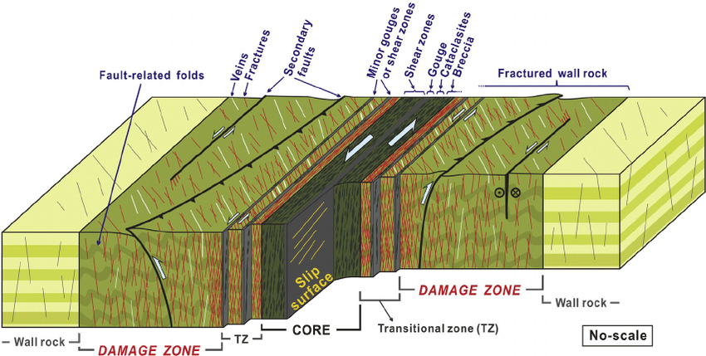

**Fig 1. Fault schematic of damage zone (Choi J.K. 2016)**

Pre-existing fractures in rock can be defined as channel-type fracture, according Ameen (2014), showing inFig 2 and Fig 3. Permeability of channel-type fractures is less stress-sensitive than that of simple “parallel-plate” fractures commonly used in laboratory experiments. The main factors influencing permeability of pre-existing fractures are geometry of the fracture shape, roughness of the fracture wall, connectivity of the fault, and mechanical aperture.

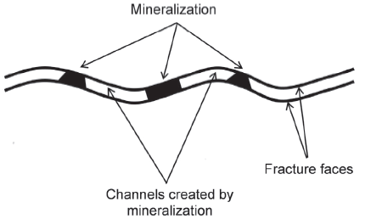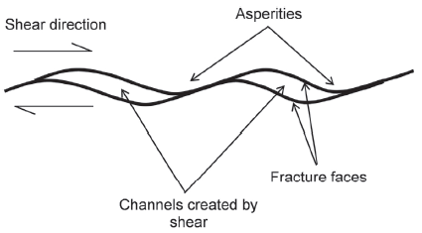

**Fig 2. Channel induced by shear displacement Fig 3. Channel induced by mineralization**

**Approach**

**Theoretical model**

In this section, we will first review fundamental fault characteristics that are very important to build our own models and then discuss the relationship of these fundamental models to the model we will build. Fault classification proposed by E.M. Anderson and critically stressed fault by Mark. Zoback will be used.

The stress of wellbore near fault will be built for scheme of fault and pre-existing fracture. Conductivity of fractures/fault will be modeled according to damage zone theory proposed by Caine (1996), and build a mathematical model associating flow pre-existing fault zone.

Then we can classify lost circulation into two categories, with-return lost circulation and total loss, as shown in Fig 7. With Nodal analysis, simply illustrated in Fig 8, with-return lost circulation, we can build the bottom hole pressure and fluid injecting rate curve, then depict out performance curve with outflow pressure and flow rate, the intersect is the pressure and flow rate seeping into formation. Besides, in terms of total loss, we can use the fluid level in the wellbore to build the model and calculate the flow pressure in wellbore. Eventually, we can use the field data to verify the conductivity mathematic model and reverse conductivity parameters.

1.1 Equilibrium Equation

$∇∙\left(σ-a_{m}pI\right)=0$ (1)

1.2 Kinematics

$ε=\frac{1}{2}[∇u+({∇u)}^{2}]$ (2)

$dσ=D_{e}dε_{e}$ (3)

1.3 Mass conservation

$\frac{∂(eφ)}{∂t}+∇∙\left(eu\right)=0$ (4)

1.4 Darcy’s law

$u=-\frac{k}{u}∇p$ (5)

1.5 Boundary Condition

$μ=\overset{̿}{u}$ $P=\overset{̿}{p}$ (6)

$σ×n=\overset{̿}{t}$ $-\frac{k}{u}{\left(∇P\right)}^{T}×n=\overset{̿}{q}$ (7)

1.6 Weak form of governing equation

$\int_{Ω}{{\left(LW\right)}^{T}σ\left(u,p\right)dΩ}-\int_{Γ_{t}}{w^{T}\overset{̿}{t}\left(u,p\right)dΓ=0}$ (8)

$\int_{Ω}{[∇W^{*}({u,p)}^{T}\left(-\frac{k}{u}∇p\right)+∇W^{*}\left({u,p)}^{T}a_{m}m^{T}L\frac{∂u}{∂t}\right]dΩ+\int_{Γ_{q}}{W^{*}{\left(u,p\right)}^{T}\overset{̿}{q}dΓ}=0}$ (9)

**eXtended Finite Element Method**

The extended finite method provides a simple and efficient treatment of cracks where the element topologies do not conform to the crack geometry. Some elements are split by the crack and others contain the crack tips. Nodes whose support is bisected by a crack are collected in *Ncr*, while nodes whose support contains the tips are grouped in the set *Ntip*,

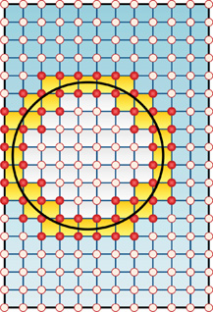

**Figure 1 Comparison of Finite Element Method and eXtended Finite Element Method**

**Computation Program**

The flow chart for the computation program. In order to build comprehensive coupling fluid flow and geomechanical simulation for the lost circulation along fault and pre-existing fractures. We build a software in C++, the flow chart for each modulus can be expressed as following:

The main function of the flow chart:

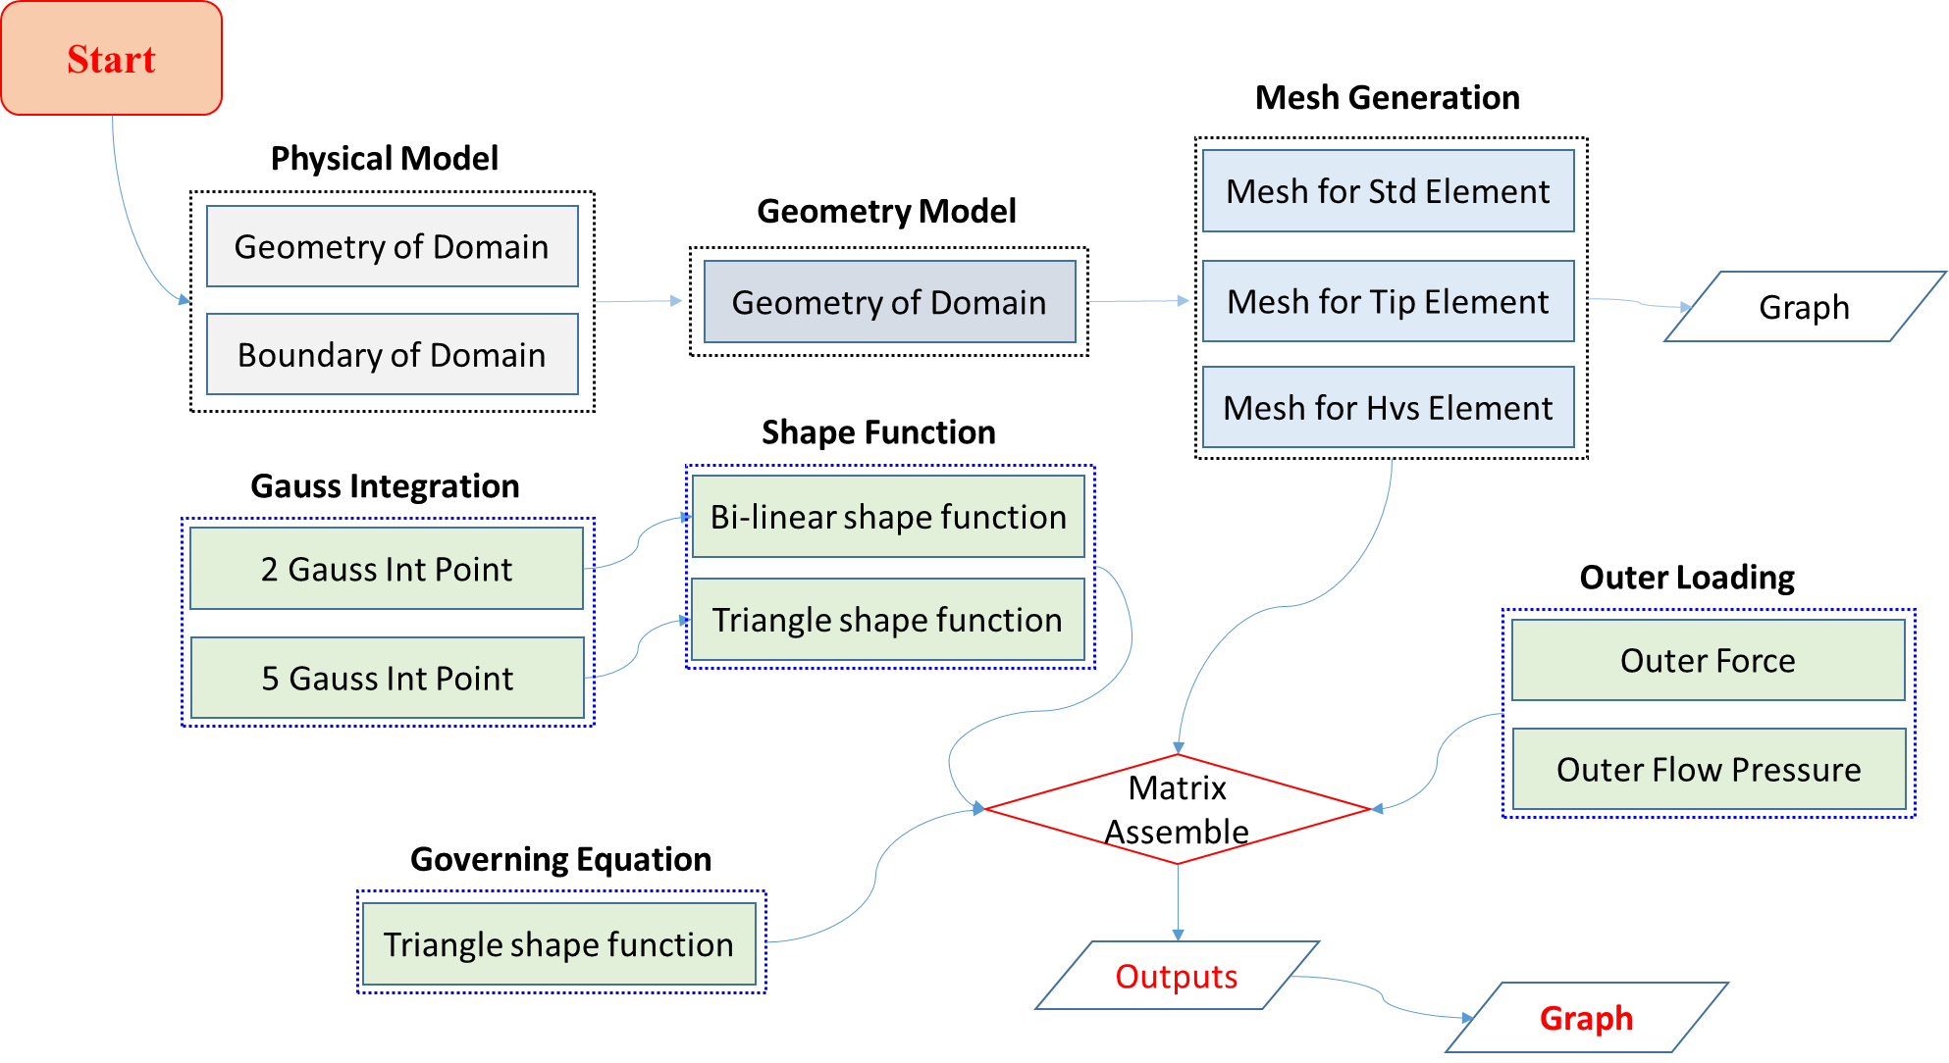

**Figure 2. Main Flow chart of the simulator in C++**

### **Input of the program:**

**Fracture information**

Domain Dimension

Drilling mud parameter

Formation Parameter

Boundary Information

Fracture information

**Fracture information**

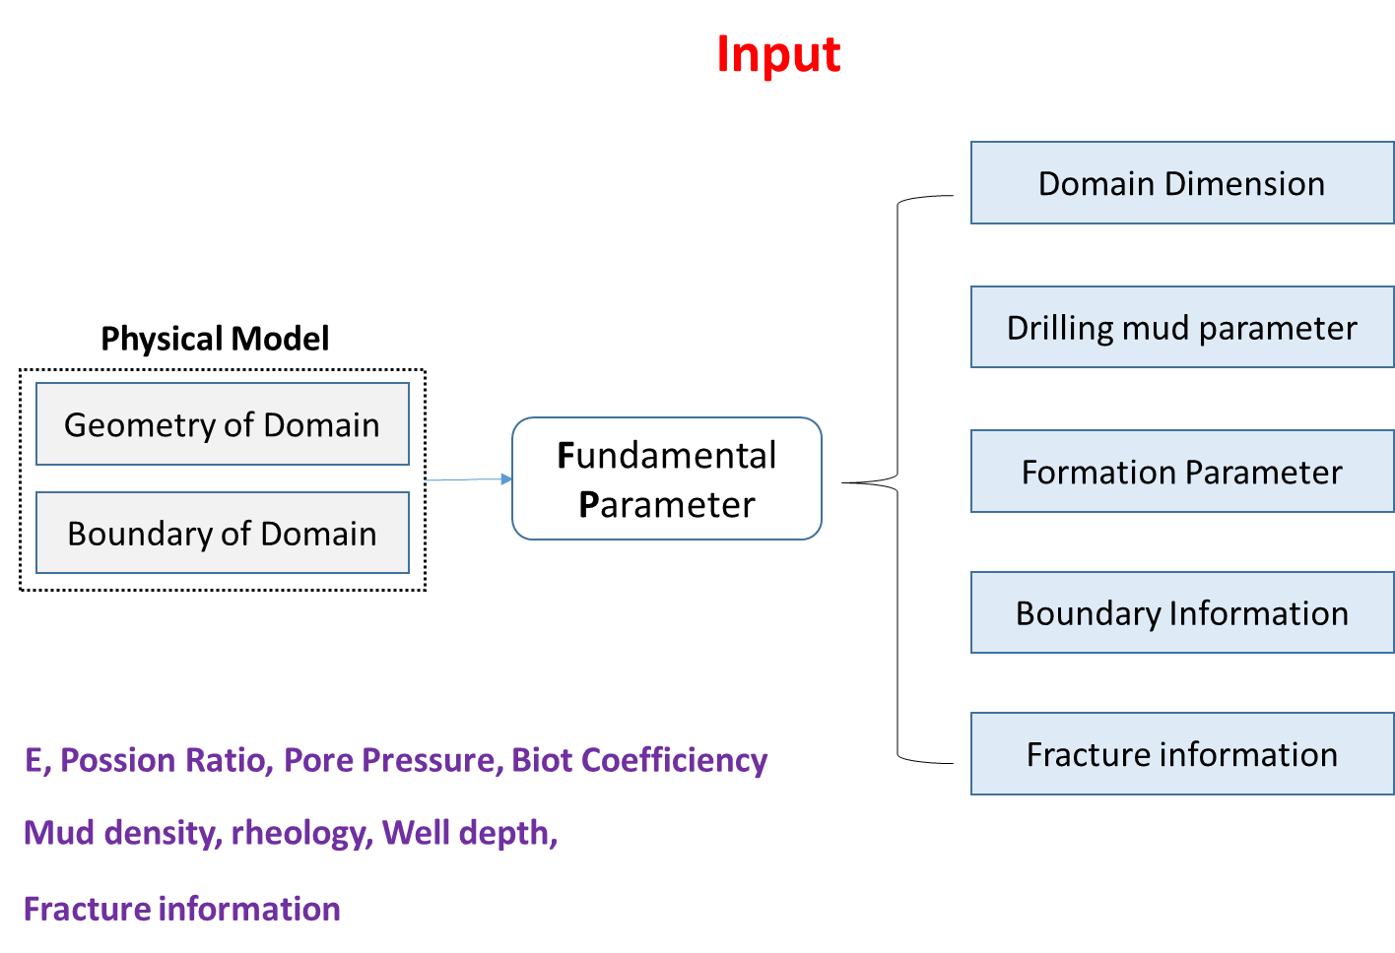

**Figure 3. Flow chart of the input in C++**

**Case Study**

In order to verify the mathematic model and simulate the crack reopening and lost circulation severity, we simulate a case according to the in-situ stress, the figure of the simulation can be expressed as following.

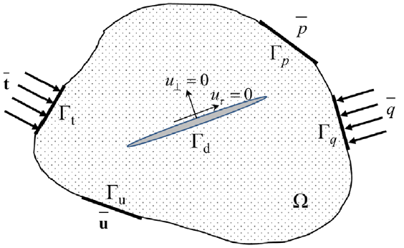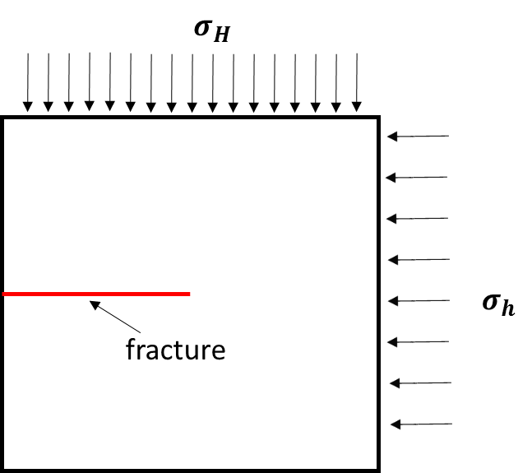

**Figure 4. Geometry of fracture model**

The input parameter can be expressed as following:

**Tab 1. Table of formation parameters and fluid parameter**

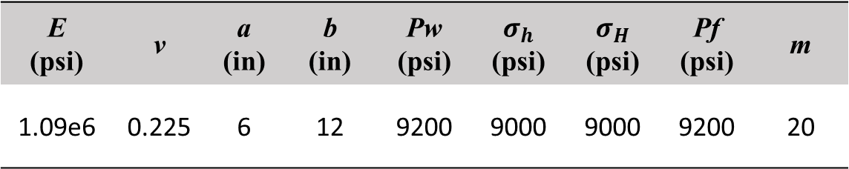

The geometry of fracture model, the geometry, the branch enriched element are showing as red dot, the Heviside enrichment element are showing as the blue elements:



**Figure 5. Geometry of the element mesh**

The element tip deformation can be expressed as following:

**Figure 6. Geometry of the crack tip**



**Figure 7. Lost circulation volume according to the deformation of crack**

**Future work**

1. Study fracture close pressure and flow back, to simulate wellbore ballooning

2. Study fracture propagation

**Code of the program:**

Domain Dimension

Drilling mud parameter

Formation Parameter

Boundary Information

Fracture information

Geometry.h

#ifndef GEOMETRY_H

#define GEOMETRY_H

#include<math.h>

#include<vector>

#include<list>

#include<iostream>

using namespace std;

class Geometry

{

public:

void Young( double E);

double Crack_Geometry(double& X1, double& X2, double& Y1, double& Y2);

void Boundary(vector<double> X, vector<double> Y);

protected:

// The Geometry Parameter of domain;

vector <double> X; // The length of the domain

vector <double> Y; // The height of the domain

// The fundamental parameter of the formation;

double E; // Young's Modulus

float Poss; // Possion's Ratio

float Pore; // Pore Pressure

float Biot;

// The fundamental parameter of the drilling mud;

double em; // Mud Density

double Rheology; // rheology of mud

double Depth;

// The fundamental parameter of the fractures; (Linear)

double Length_Crack;

double X1;

double Y1;

double X2;

double Y2;

};

// Crack geometry, the straight line mode

double Crack_Geometry(double& X1, double& X2, double& Y1, double& Y2)

{

double X_Crack = NULL;

double Crack_theta = (Y2 - Y1) / (X2 - X1);

double b = Y1 - Crack_theta*X1;

double Crack = Crack_theta*X_Crack + b;

return Crack;

};

#endif

#ifndef GEOMETRY_INFO_H

#define GEOMETRY_INFO_H

#include<math.h>

#include<valarray>

#include<vector>

#include<map>

#include<iostream>

#include<limits>

#include<assert.h>

using namespace std;

// creat a package for the geometry

namespace rui

{

typedef enum GeometryType

{

NULL_GEOMETRY,

CIRCLE,

TRIANGLE,

RECTANGLE,

CONVEX_POLYGON,

SEGMENTED_LINE,

TETRAHEDRON

};

class Segment;

class ConvexPolygon;

class Point

{

public:

double x;

double y;

double z;

int id;

Point();

Point(double x, double y);

Point(double x, double y, double z);

void setX(double W);

void setY(double W);

void setZ(double W);

void set(double W, double WW); // Set two demension

void set(double W, double WW, double WWW); // Set three demension

void set(const Point p);

void set(const Point *P);

///////////////define bool identification for points////////////

bool operator ==(Point P) const;

bool operator !=(Point P) const;

bool operator < (Point P) const;

bool operator > (Point P) const;

////////// define operator for point////////////////////////

Point operator -(Point P) const;

Point operator-(Vector P) const;

Point operator +(Point P) const;

Point operator+(Vector P) const;

Point operator/(double P) const;

Point operator*(double P) const;

double operator*(Point P) const;

double operator*(Vector P) const;

Point operator ^(Point P) const;

Point operator^(Vector P) const;

void operator+=(Point P);

double norm() const; //Set MATLAB norm() function

double sqNorm() const;

void print() const;

double angle() const;

double & operator[](size_t i);

double operator[](size_t i) const;

};

////////////////////define line in the geometry///////////

class Line

{

protected:

Point P;

Point v;

public:

Line(Point origin, Point vector);

bool intersects(const Line *l) const;

bool intersects(const Segment *s) const;

bool intersects(const Geometry *g) const;

bool on(const Point *P) const;

vector<Point> intersection(const Geometry * g) const;

Point intersection(const Line *l) const;

Point intersection(const Segment *l) const;

const Point * vector() const;

const Point * origin() const;

Point projection(const Point *P) const;

};

//////////////////////Segment of the domain ///////////////////

class Segment

{

protected:

Point f;

Point s;

Point mid;

Point vec;

public:

Segment(const Point P0, const Point P1);

Segment();

virtual ~Segment();

bool intersections(const Line *l) const;

bool intersections(const Segment *s) const;

bool intersections(const Geometry *g) const;

bool on(const Point *P) const;

void setFirst(Point P);

void setFirst(double x, double y);

void setSecond(Point P);

void setSecond(double x, double y);

void set(Point P0, Point P1);

void set(double x0, double y0, double x1, double y1);

void print() const;

const Point * first() const;

const Point * second() const;

Point * first();

Point * second();

Point intersection(const Line *l) const;

Point intersection(const Segment *l) const;

vector<Point> intersection(const Geometry * g) const;

};

/////////////////////// Geometry of the domain//////////////////

class Geometry

{

protected:

std::valarray<Point *> *inPoints;

bool sampled;

Point center;

virtual void computeCemter() = 0;

GeometryType gType;

public:

Geometry();

Geometry(size_t numPoints);

virtual ~Geometry() { delete inPoints; }

virtual std::valarray<Point *> * getBoundingPoints() const = 0;

virtual Point* getBoundingPoint(size_t i) const = 0;

virtual std::valarray<Point *> * getInPoints() const;

virtual Point* getInPoint(size_t i) const;

virtual Point * getPoint(size_t i) const = 0;

virtual const Point * getCenter() const;

virtual Point * getCenter();

virtual void project(Point *) const = 0;

GeometryType getGeometryType() const;

virtual double getRadius() const = 0;

virtual void sampleBoundingSurface(size_t num_points) = 0;

virtual void sampleSurface(size_t num_points) = 0;

virtual bool in(const Point p) = 0;

virtual bool in(const Point *p) const{ return false; }

virtual size_t size() const = 0;

virtual double area() const = 0;

virtual size_t sides() const { return 3; }

virtual bool is1D() const = 0;

};

class PointSet

{

protected:

valarray<Point *>* boundingPoints;

size_t chullEndPos;

public:

PointSet();

PointSet(size_t npoints);

virtual ~PointSet() { delete boundingPoints; }

double x(size_t i);

double y(size_t i);

double z(size_t i);

void setX(size_t i, double v);

void setY(size_t i, double v);

void setZ(size_t i, double v);

void set(size_t i, Point *p);

void set(size_t i, double x, double y);

void set(size_t i, double x, double y, double z);

Point * operator [](size_t i);

Point * operator [](size_t i) const;

Point * getPoint(size_t i) const;

Point * getPoint(size_t i);

virtual bool in(const Point p);

virtual size_t size() const;

void removePoint(size_t index);

Point * computeCenter();

ConvexPolygon * convexHull();

typedef Point** iterator;

iterator begin() const;

iterator end() const;

};

class NonConvexGeometry : public PointSet, public Geometry

{

protected:

valarray<Point *> orderedSet;

vector<size_t> stopPos;

public:

NonConvexGeometry(); // constructor

NonConvexGeometry(size_t numPoints);

NonConvexGeometry(PointSet * p);

virtual ~NonConvexGeometry(){ }; //destructor

virtual valarray<Point *> * getBoundingPoints() const;

virtual Point* getBoundingPoint(size_t i) const;

virtual Point* getPoint(size_t i) const;

virtual size_t size() const;

virtual double area() const = 0;

virtual void project(Point *) const = 0;

};

class ConvexPolygon : public PointSet

{

public:

ConvexPolygon(size_t npoints);

ConvexPolygon(PointSet * po);

virtual ~ConvexPolygon();

virtual bool in(const Point p);

virtual bool in(const Point p) const;

virtual bool in(const Point *p) const;

virtual bool isTrigoOriented() const;

};

class ConvexGeometry : public ConvexPolygon, public Geometry

{

public:

ConvexGeometry();

ConvexGeometry(size_t numPoints);

virtual ~ConvexGeometry(){ };

virtual valarray<Point *>* getBoundingPoints() const;

virtual Point* getBoundingPoint(size_t i) const;

virtual void sampleBoundingSurface(size_t num_points) = 0;

virtual void sampleSurface(size_t num_points) = 0;

virtual Point * getPoint(size_t i) const;

virtual size_t size() const;

virtual double area() const = 0;

virtual void project(Point *) const = 0;

};

}

#endif